LoRa Low Power Long Range Radio Information.

July 21, 2017

LoRa is a proprietary spread spectrum modulation scheme that is derivative of Chirp Spread Spectrum modulation (CSS) and which trades data rate for sensitivity within a fixed channel bandwidth.

What is LoRa wireless?

<http://www.rfwireless-world.com/Terminology/LoRa-technology-basics.html>

LoRa stands for Long Range Radio. It is the wireless technology mainly targetted for M2M and IoT networks. This technology will enable public or multi tenant networks to connect multiple applications running in the same network. This LoRa technology will fulfill to develop smart city with the help of LoRa sensors and automated products/applications.

LoRa Alliance formed to standardize LPWAN (Low Power Wide Area Network) for M2M/IoT. The prospective members in this alliance are Actility, Cisco, Bouygues Telecom, Proximus, SingTel, Semtech, Swisscom, IBM, SingTel, KPN etc. The LoRa Alliance will drive global success of LoRa Protocol i.e. LORA WAN.

Key Features:

| **Specification/feature** | **LoRa Support** |
| --- | --- |
| Range | 2-5 Km in dense urban and 15 Km in suburban areas |
| Frequency band | ISM band 868 MHz and 915 MHz |
| Standard | IEEE 802.15.4g |
| Modulation | spread spectrum modulation type is used which uses wide-band linear FM pulses. The frequency increase or frequency decrease over certain period is used to encode data information to be transmitted. It gives 30dB improvement over FSK. |
| Capacity | One LoRa gateway takes care of thousands of nodes. |
| Battery | Longer battery life |
| **LoRa Physical layer** | Takes care of frequency, power, modulation, signalling between nodes and gateway |

14 LoRa FAQs answered:

<https://www.link-labs.com/blog/lora-faqs>

Most of this information is for the LoRa Device Shield for Arduino found at MCM for $12.00

(This is one of the lowest cost LoRa boards that I’ve found)

<http://www.mcmelectronics.com/product/83-17951>

**Lora Radio Shield**

This Lora Radio Shield is base on Low-cost LoRa Module, learn more about Low-cost [**LoRa Module**](http://www.linksprite.com/wiki/index.php5?title=Low-cost_LoRa_Module)

Thanks to this open source project which uses the Raspberry Pi as Lora gateway and Arduino as Lora node device. We port this project to pcDuino and send the received data from Lora node to LinkSpriteIO

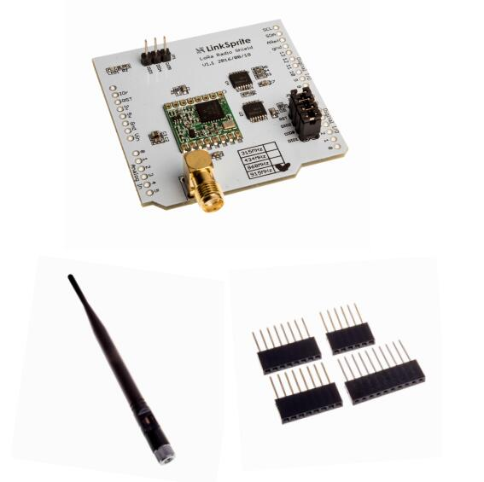

And a close up of the main chip

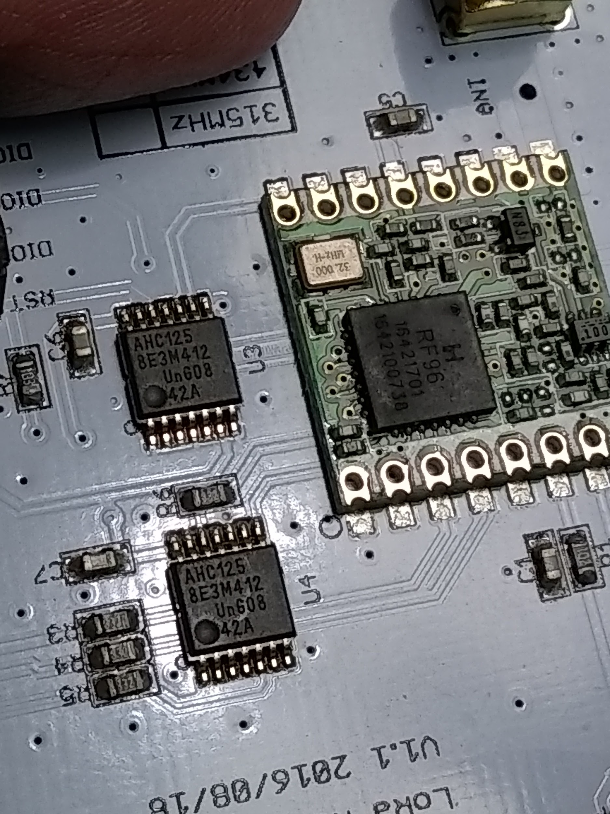

This shield can be used to setup a Gateway (using the PCDuino Uno8) and a Node.

(Finally a reason to use the UNO8)

As out lined in this document <http://linksprite.com/wiki/index.php5?title=DIY_low-cost_LoRa_gateway_based_on_pcDuino#2._Program_Arduino_Uno>

Low-Cost LoRa Module

<http://www.linksprite.com/wiki/index.php5?title=Low-cost_LoRa_Module>

Linksprite libraries:

<https://github.com/YaoQ/pcduino-lora-AP>

<https://github.com/YaoQ/RF95-LoRa-D1-Arduino>

<https://github.com/YaoQ/arduino-lmic>

<https://github.com/YaoQ/LoRaGateway>

Specifications: (Copied from the Low Cost LoRa Module Wiki)

* LoRa Modem.
* 168 dB maximum link budget.
* +20 dBm - 100 mW constant RF output vs. V supply.
* +14 dBm high efficiency PA.
* Programmable bit rate up to 300 kbps.
* High sensitivity: down to -148 dBm.
* Bullet-proof front end: IIP3 = -12.5 dBm.
* Excellent blocking immunity.
* Low RX current of 10.3 mA, 200 nA register retention.
* Fully integrated synthesizer with a resolution of 61 Hz.
* FSK, GFSK, MSK, GMSK, LoRaTM and OOK modulation.
* Built-in bit synchronizer for clock recovery.
* Preamble detection.
* 127 dB Dynamic Range RSSI.
* Automatic RF Sense and CAD with ultra-fast AFC.
* Packet engine up to 256 bytes with CRC.
* Built-in temperature sensor and low battery indicator.

Other Important information to know: (If using the RadioHead Library)

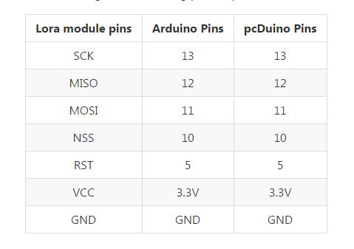

HopeRF RF-96 PDF datasheet:

<http://www.hoperf.com/upload/rf/RFM69HW-V1.3.pdf>

Another DIY Low Cost LoRa Gateway

<http://cpham.perso.univ-pau.fr/LORA/RPIgateway.html>

RadioHead Packet Radio library (referenced by Linksprite and most other LoRa projects)

<http://www.airspayce.com/mikem/arduino/RadioHead/>

LoRa for Ham Radio (Using 70cm 433mhz)

<https://github.com/travisgoodspeed/loraham>

<https://www.thethingsnetwork.org/forum/t/lora-based-ham-radio-network/2831/5>

Ham Frequency Allocations (In the ISM band)

### **70 Centimeters**

*All Amateurs except Novices:*

420.0-450.0 MHz: CW, Phone, Image, MCW, RTTY/Data

### **33 Centimeters**

*All Amateurs except Novices:*

902.0-928.0 MHz: CW, Phone, Image, MCW, RTTY/Data

FCC Rules for ISM bands

<http://afar.net/tutorials/fcc-rules/>

SemTech LoRa Modulation Basics PDF

<http://www.semtech.com/images/datasheet/an1200.22.pdf>

LoRa Channel Information:

<http://www.rfwireless-world.com/Tutorials/LoRa-channels-list.html>

Following table-2 lists out LoRa channels in 900 MHz Band. The band is from 902 to 928 MHz. It mentions channel number and its respective channel frequency. All the 13 channels are separated by 2.16 MHz with respect to the adjacent channels

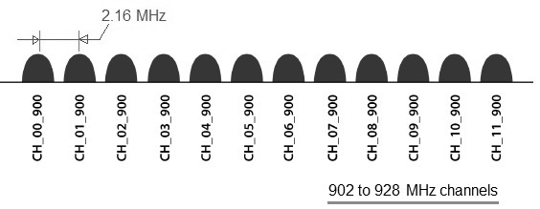

| **Channel Number** | **LoRa Center Frequency** |
| --- | --- |
| CH_00_900 | 903.08 MHz |
| CH_01_900 | 905.24 MHz |
| CH_02_900 | 907.40 MHz |
| CH_03_900 | 909.56 MHz |
| CH_04_900 | 911.72 MHz |
| CH_05_900 | 913.88 MHz |
| CH_06_900 | 916.04 MHz |
| CH_07_900 | 918.20 MHz |
| CH_08_900 | 920.36 MHz |
| CH_09_900 | 922.52 MHz |
| CH_10_900 | 924.68 MHz |
| CH_11_900 | 926.84 MHz |
| CH_12_900 | 915 MHz |

### **LoRaWAN for North America**

LoRaWAN defines 64, 125 kHz channels from 902.3 to 914.9 MHz increments.

There are an additional eight 500 KHz uplink channels in 1.6 MHz increments from 903 MHz to 914 MHz. The eight downlink channels are 500 kHz wide starting from 923.3 MHz to 927.5 MHz.

The maximum output power for North America is +30 dBM.

Semtech vs HopeRF (SX12xx vs RF69) or IS it a clone or the real thing:

Copied from this forum post: <https://lowpowerlab.com/forum/rf-range-antennas-rfm69-library/rfm69-hoperf-are-they-semtech-clones-or-not/>

The HopeRF RFM69 modules use genuine Semtech chips. I have decapped these chips to verify this. They are custom packaged hence you see a Hope logo and "RF69" markings on them and not the default semtech markings. Take the following facts:

- if HopeRF would be using a cloned silicon design, and since Semtech owns patents and the IP they and would sue and stop imports in the civilized world where laws actually still work (US, EU). So Hope would have no market there

- the packages for HopeRF's RF69 chips are QFN28, perhaps a little cheaper to package in China or Thailand/Taiwan. I bet it's a magnitude cheaper to buy the silicon or straight out wafers and doing the custom packaging with subcontracting, allowing Hope to make the chip appear proprietary. That's great for HopeRF and for all the rest of us, we get the same genuine chips, at a low price, win-win for all.

- the Semtech packaging is QFN24

- the HopeRF RFM69 radio variants are based on the stock Semtech reference designs found [on pages 76/77 of the datasheet](http://www.semtech.com/images/datasheet/sx1231h.pdf)

- the reason (implied) for HopeRF's copycat datasheets is that they are not selling the chip itself, but a reference design based on the original chip. So ***of course*** they have to change the datasheet to reflect these changes and pinout diagrams, and in doing so they slapped their logo on it (if Semtech doesn't complain why would anyone else?). It's unfortunate that there are some errors in the datasheets but if one of us had to do the same and translate a chinese datasheet with your own changes added, I wonder how well we'd do. What bothered me somewhat is that they just replaced "Semtech"

- the concept of fake not only scares but annoys me. If these were fake and buggy and not performant modules I would not use/resell or endorse them, instead I would make my own. In fact I made a batch of RFM69 just for fun to prove myself I can do it. I bought Semtech chips and followed their reference design which is very close to what HopeRF did. But to get close to make it worth it for me to keep making these I would have to make them in 10,000qty and spend half my time doing it. Hence I prefer to source from HopeRF, that's all they do on a massive scale and they do a fine job. It's one of the Chinese products that is of good quality. Thumbs up from me, I hope they don't screw up in the future.

- internet statements claiming HopeRF modules are low quality pivot on the fact that some of the SMD components are reflowed at dodgy angles making it look like the design is sloppy. I see something else: - they use the same PCB for half a dozen variants of RFM69 and hence most pads are smaller than optimal for reflowing and some pads are shared, so some pads are not always identical or perfectly square with others etc. So yeah - at that scale reflowing will pull the parts wherever there is more surface tension. Perhaps an optimization rather than a compromise and another reason the price is so "low".

Notice the Semtech SX1231H chip markings and the HopeRF RF markings:

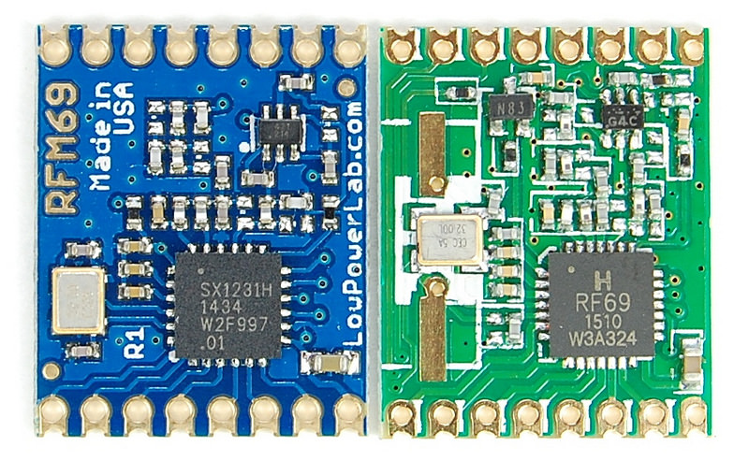

That’s all for now….stay tuned.